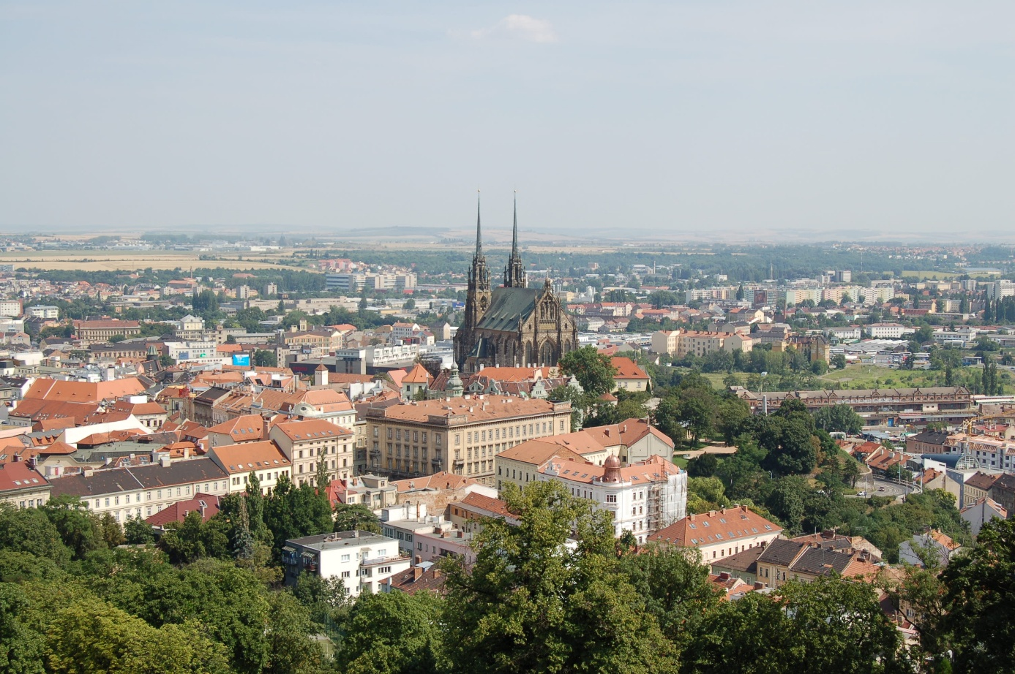

Program of the
Water Days in Brno 2026
21st-27th of March 2026

Organizers:
Michaela Menšíková: michaela.mensikova@mendelu.cz, +420771125473
Michaela Tichá: Michaela.ticha@mendelu.cz

Saturday March 21st

 | What | Time | Where | Note
 | World Water Days-Lipka-group tasks | 9:00-12:00 | Lipka, Brno-Soběšice čp. 97, Soběšice, 644 00 Brno: https://maps.app.goo.gl/aP3T8VpyJyagdKAZ6 | Be prepared for outdoor  stay
 | Lunch | 12:30 - 13:30 | Hospůdka u Divošky, Trtílkova 24, Brno:  https://maps.app.goo.gl/vsGp8BCSmeq5wAoX8 | This lunch will be on your expense (probably the best pizza in Brno ). Team Blue and Red have reservation at 12:00, Team Yellow and Green at 13:30

Sunday March 22nd

 | What | Time | Where | Note
 | Visit to Civil Engineering VET School, excursion Flood protection measures in Brno | 9:30 - 14:30 | Kudelova 1855/8, 662 51 Brno: https://maps.app.goo.gl/4hFfRzCNkizFW5vr8 | Small snack is prepared for you in the school and than you go for two showcases of flood protection measures outdoors. You will have some free time to arrange your lunch before going to university
 | Teamspirit (15'), Warm-up - getting to know each other.Presentation of the countries/schools (5 minutes per school) | 14:30 –  17:30 | Campus of Mendel Universit in Brno, Zemědělská 1, Building X: https://maps.app.goo.gl/AZwRSZ52DR6D3sus7 | Small snack will be ready for you
 | Pub Quizz | 18:00 - 22:00 | Na Škopek, Provazníkova 890/40613 00 Brno-sever-Černá Pole:  https://maps.app.goo.gl/EoBWP3FrP9RegQhj9 | Dinner is for you ready in the pub you need to cover for your drinks only.

Monday March 23rd

 | What | Time | Where | Note
 | Introduction to the topic | 9:30 - 11:00 | Campus of Mendel Universit in Brno, Zemědělská 1, Building X: https://maps.app.goo.gl/AZwRSZ52DR6D3sus7 | Whole day is at MENDELU campus, mostly inside, food is ready and water for drinking available the whole time
 | Coffee break | 11:00 - 11:30 | Campus of Mendel Universit in Brno, Zemědělská 1, Building X:  https://maps.app.goo.gl/AZwRSZ52DR6D3sus8
 | Presentation skills | 11:00 - 12:30 | Campus of Mendel Universit in Brno, Zemědělská 1, Building X: https://maps.app.goo.gl/AZwRSZ52DR6D3sus9
 | Lunch | 12:30 - 13:15 | Campus of Mendel Universit in Brno, Zemědělská 1, Building X:  https://maps.app.goo.gl/AZwRSZ52DR6D3sus10
 | Team cooperation and communication | 13:15 - 14:00 | Campus of Mendel Universit in Brno, Zemědělská 1, Building X: https://maps.app.goo.gl/AZwRSZ52DR6D3sus11
 | Mendelu campus carousel | 14:00 - 15:00 | In front of M Building
 | Coffee break | 15:00 - 15:30 | Campus of Mendel Universit in Brno, Zemědělská 1, Building X:  https://maps.app.goo.gl/AZwRSZ52DR6D3sus7
 | Teamwork - preparation for the project | 15:30 - 16:30 | Campus of Mendel Universit in Brno, Zemědělská 1, Building X:  https://maps.app.goo.gl/AZwRSZ52DR6D3sus7
 | Free-time | 16:30 - 18:00
 | City Tour - Beer History | 18:00 -20:00 | Statue of Margrave Jobst of Luxembourg, https://maps.app.goo.gl/cxJcj9BySX7g2eA78 | Team Red and Yellow - you will have a professional guide for the trip, for the consumption you need to cater yourself.


Tuesday March 24th

 | What | Time | Where | Note
 | Departure to fieldtrip | 8:00 | Campus of Mendel Universit in Brno, Zemědělská 1, Building A | Be prepared for outdoor stay
 | Fieldtrip Moravský kras - water sampling, Jedovnice - wastewater treatment plant | 9:00 - 17:00 | Moravský kras
 | Get together - dinner, folk music ... | 18:30 -22:00 | Campus of Mendel Universit in Brno, Zemědělská 1, Building X upstairs | You can bring your national costumes for dancing.

Wednesday March 25th

 | What | Time | Where | Note
 | Departure to fieldtrip | 7:45 | Campus of Mendel University in Brno, Zemědělská 1, Building A | Be prepared for outdoor stay
 | Fieldtrip Hranický kras - water sampling in different locations | 10:00- 17:00 | Hranický kras
 | City Tour - Beer History | 18:00 -20:00 | Statue of Margrave Jobst of Luxembourg:  https://maps.app.goo.gl/cxJcj9BySX7g2eA78 | Team Blue and Green - you will a professional guide for the trip, for the consumption you need to cater yourself.

Thursday March 26th

 | What | Time | Where | Note
 | Warm-up/Pitch preparation/Laboratory measurement | 9:30 - 12:00 | Campus of Mendel Universit in Brno, Zemědělská 1, Building X/Q | Whole day is at MENDELU campus, mostly inside, food is ready and water for drinking available the whole time.
 | Lunch | 12:00 - 13:00 | Campus of Mendel Universit in Brno, Zemědělská 1, Building X/Q
 | Laboratory measurement/Pitch preparation/Mentoring meetings for all groups | 13:00 - 17:30 | Campus of Mendel Universit in Brno, Zemědělská 1, Building X/Q

Friday March 27th

 | What | Time | Where | Note
 | Last preparations of the pitches | 8:30 - 9:00 | Campus of Mendel Universit in Brno, Zemědělská 1, Building X
 | Recap of the week - photos | 9:00 - 9:15 | Building X | Whole morning is at MENDELU campus, mostly inside, food is ready and water for drinking available the whole time.
 | Student's project presentations 1 – feedback and discussion | 9:45 - 11:00 | Auditorium
 | Coffee break | 11:00 - 11:15 | Auditorium
 | Student's project presentations 2 – feedback and discussion | 11:15 - 12:30 | Auditorium
 | Final words | 12:30 - 12:45 | Auditorium
 | Lunch | 12:45 - 13:30 | Building X

