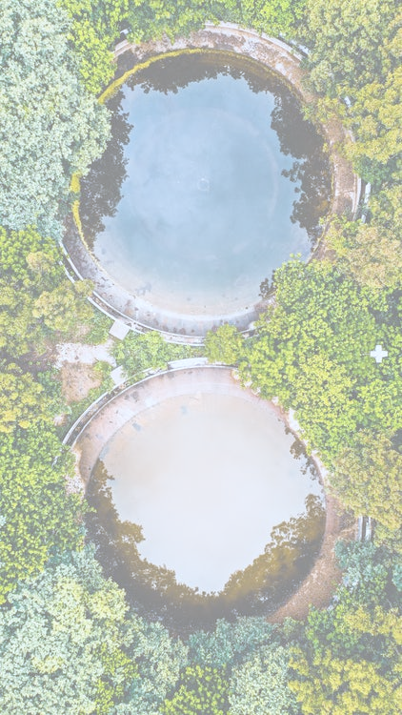

PLATFORM OF VOCATIONAL EXCELLENCE WATER - Scale up Project
Thematic lecture & Study trips for policy makers on topic:

DIGITALISATION AND NATURE-BASED-SOLUTIONS FOR WASEWATER TREATMENT

Brno, Czech Republic, 24 –25 November 2025

About PoVe Water
Platform of Vocational Excellence Water  Implementing a new way of educating people to make sure they are the sustainable water sector professionals that society and the labour market needs.  Our why  PoVE Water operates in a society in transition, where values such as sustainability, corporate responsibility and social value creation are becoming increasingly important. This development goes hand in hand with trends in the water sector labour market. The sustainable availability of people and the utilisation and further development of available talent are becoming central. Twenty-three partners from Europe and South-Africa work together with this vision in mind, convinced that a new way of educating people is needed to make sure they are the agile and sustainable water sector professionals that our society and the labour market needs. | 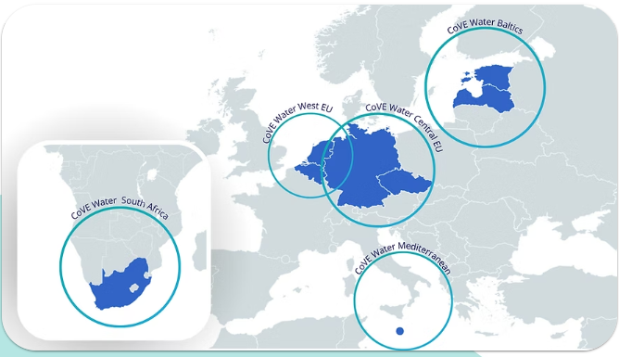

Meeting Agenda
 | Monday November 24th, venue – (TBC)
 | What | Time | Who
1 | Registration, coffee | 9:00-9:30 | All participants
2. | Welcome words by Jihomoravský kraj/CREA Hydro&Energy/ /CoVE Water Central Europe | 9.30 - 9.45 | Břetislav Skácel/ Jan Zámečník
3. | Discussion - Regional statistical data on wastewater treatment plants (WWTP) | 9:45 - 10:00 | Jānis Zviedris (Riga Technical university/ CLEANTECH LATVIA)
  PE band | CZ | EE | LV | NL | MT | SA
  >100,000 | 9 | 2 | 1 | ~55–65 | 1 | ~10–15
  10,000–100,000 | ~150 | ~13 | ~20–25 | ~185–205 | 2 | ~170–220
  2,000–10,000 | ~489 | ~30–40 | ~32–37 | ~40–55 | 0 | ~200–260
  <2,000* | NA | ~600–650 | ~900 | ~3–10 | 0 | ~380–520
4. | Comparison of specific numeric limits for BOD₅, COD, TSS, N, P under directive 91/271/EEC and (EU) 2024/3019 | 10:00 - 10:15 | Jānis Zviedris (Riga Technical university/ CLEANTECH LATVIA)
5. | Requirements for operator self-monitoring & testing carried out by the Environmental Service | 10:15 – 10:30 | Vita Līcīte (State Environmental Service, Latvia)
6. | Coffee break | 10:30 - 10:45 | All participants
7. | Digitalisation opportunity for wastewater quality monitoring in WWTP – case study from Ugāle municipality | 10:45 - 11:15 | Jānis Rubulis (Riga Technical university/Waterson technologies)
8. | ASIO, spol. s r.o. – Design of wastewater treatment plants | 11:15 - 11:35 | Karel Plotěný (ASIO)
9. | Designtec, s.r.o. – advantages of using digital twins | 11:35 - 11:55 | Petr Vymlátil (Designtec)
10. | Lunch | 11.55 – 12.55 | All participants
11. | Infiltration and inflow in sewer networks  Impacts of groundwater level and precipitation on wastewater flow | 12:55-13:15 | Gints Dakša (Jurmala Water Ltd/Tallinn University of Technology)
12. | The impact of active tourism on wastewater treatment plants - case study from Jūrkalne and Jūrmala municipality | 13:15 - 13:35 | Jānis Zviedris (Riga Technical university/ CLEANTECH LATVIA)
13. | Coffee break | 13:35 - 13:45 | All participants
14. | Use of wetlands in wastewater treatment - case study from Czech Republic  https://www.youtube.com/watch?v=tYaavnswv8A | 13:45-14:15 | Jan Vymazal (CZU, Česká zemědělská univerzita v Praze)
14. | Use of wetlands in wastewater treatment - case study from Limbaži | 14:15-14:35 | Linda Grīnberga (Latvia University of Life Sciences and Technologies)
15. | Wrap-up of day 1  Round table discussion | 14:35 - 15:35 | Moderator + region stakeholders
16. | Visit of the city centre – Free Time |  | All participants
17. | Dinner | Tbc  18:30 - 20:00 | All participants
 | Tuesday November 25th , venue – Morning session (TBC) Afternoon session (Faculty of Business Mendel University in Brno, Zemědělská 1665)
 | What | Time | Who
1. | Coffee | 9:00-9:30 | All participants
2. | Matchmaking at Technical University of Brno/ Participation in Water4All | 9:30-10:00 | tbc
3. | Brno–Modřice Wastewater Treatment Plant  Brněnské vodárny a kanalizace, a.s., Svratecká 989, 664 42 Modřice, Czechia | 10.00 – 11.30 | All participants
4. | Lunch | 11.30 – 12:00 | All participants
5. | Visit to Water Tanks under Žlutý Kopec  Tvrdého 15, 602 00 Staré Brno, Czechia | 12:00-13:30
6. | “Regulated versus natural flow” VR APP individual testing | 14:00-16:30 | Petr Zálešák &team (Mendel University in Brno)
9. | Feedback round | 16.30 – 17.00 | All participants

Venue trip to Brno
TBC
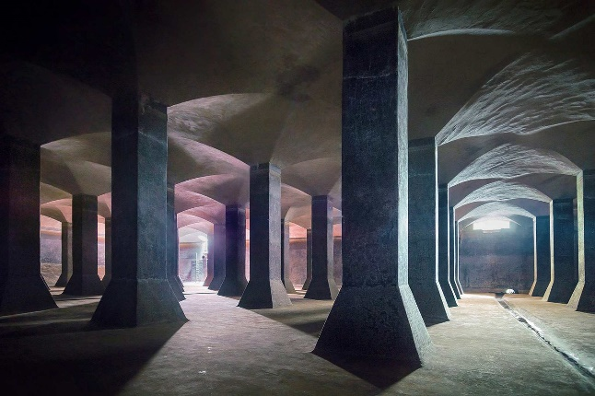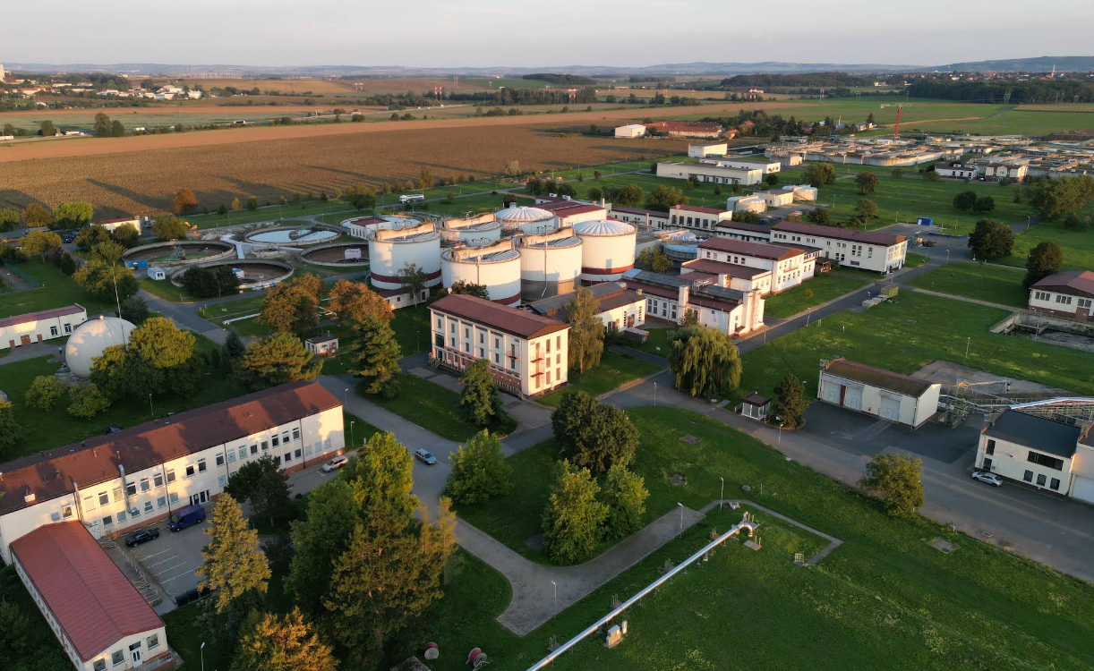
Registration
Please register for the meeting by Friday 24nd October 2025 by using the link below:

https://docs.google.com/forms/d/e/1FAIpQLSfitzD6YowggWImxKOoXlbtURj9ByK9m435MQFjJCiFe6fk8Q/viewform?usp=header

Presenters/Organisers

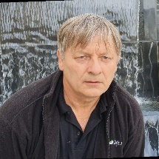 |  | 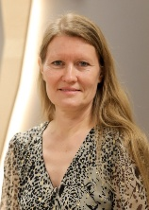 |  |  |  | 
Karel Plotěný | Petr Vymlátil | Vita Līcīte | Michaela Menšíková | Linda Grīnberga | Jan Vymazal | Gints Dakša
 | 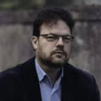 |  | 
 | Jānis  Zviedris | Břetislav Skácel | Jānis  Rubulis

How to get to Brno from Prague or Vienna airport
FROM PRAGUE BY BUS
There are several bus companies operating buses from Prague to Brno:
- Student Agency (RegioJet)
- Flixbus
- Eurolines

The yellow Student Agency (RegioJet) buses also leave directly from Prague’s Vaclav Havel airport (you will have to transfer at the main bus station Florenc in Prague, but one ticket is valid for the whole journey to Brno by both buses). There is a ticket office of Student Agency at Terminal 1 in Prague, but you can also buy your ticket in advance and pay by credit card – it is really convenient. Flixbus, Eurolines and other companies operate buses from the bus station Florenc – you can get there by another bus operated by Student Agency or ask for directions at the airport. Student Agency and Flixbus will drop you off at the Grand Hotel bus station in Brno, while other companies usually stop at Zvonařka bus station.

FROM PRAGUE BY TRAIN
To get to Brno by train, you will first need to get to Prague’s main railway station – you can go by Airport Express, by public transport or ask for directions at the airport. You can buy your ticket online: https://www.cd.cz/en, of the Regiojet Company, or at the train station. Please do not forget to count at least 2 hours extra time to get to the railway station from the airport – it does not take that long, but since you do not know the way, you must count some extra time to find it and time to buy the ticket at the railway station to be on the safe side!
- Plan of Vaclav Havel Airport: https://www.prg.aero/en/map-airport
- Interactive clickable plan of Florenc Coach Station (the main bus station in Prague): https://florenc.cz/index.php?site=an&usite=mapy&sel=mnad&lan=en
- You can check the bus and train schedules, as well as buy the tickets online: https://idos.idnes.cz/en/vlakyautobusy/spojeni

FROM VIENNA BY BUS
Student Agency, Gepard Express and Flixbus operate direct buses from Vienna’s Schwechat airport and all stop at the Grand Hotel bus station in Brno.

FROM VIENNA BY TRAIN
You can also travel from Vienna airport by train –there is a railway station in front of the arrival’s hall. The first option is to go by direct train from the airport to Brno, which runs three times a day. You can check the schedule and buy a ticket online: https://regiojet.com . The second option is to change trains at Wien Hauptbahnhof (the main station) or in Břeclav. In that case, please check this page: https://www.oebb.at/en , where you can also
Buy tickets online. Type Flughafen Wien or Vienna Schwechat airport in the “From” field and Brno hl. n. in the “To” field.
- Plan of Vienna Schwechat Airport:

https://map.viennaairport.com/apps/index.html?rel=en

